SIMATS ENGINEERING (SAVEETHA SCHOOL OF ENGINEERING)
Department of Computer Science and Engineering
ASSESSMENT TOOL 3 – CASE STUDY
Course Code: | CSA06 | Course Title: | Design and Analysis of Algorithms
CO Assessed: | CO3: Articulation (BL4, BL5) | Assessment: | Assessment Tool 3 – Case Study
Weightage: | 20% of CIA | Total Marks: | 100 (2 Questions × 50 Marks)
CO3 Statement: | Design Divide and Conquer algorithms for Merge Sort, Quick Sort, Binary Search and Matrix Multiplication
Student Name: | S.MAHALAKSHMI | Reg. No.: | 192524372
Section / Batch: | 2MD YEAR | Date: | 20/08/26

Instructions to Students
- Answer both questions. Each question carries 50 Marks. Total: 100 Marks.
- Carefully analyze the given case study questions.
- Explain in detail with sample code if needed.
- Clearly identifies all key issues, in-depth analysis, Innovative, feasible solutions with strong justification

Question Type | Description | Questions | Total Marks
Case Study | Focus on Design Divide and Conquer algorithms: Merge Sort, Quick Sort, Binary Search and Matrix Multiplication | Q1 – Q2 | 100

SECTION A – CASE STUDY

QUESTION 1:

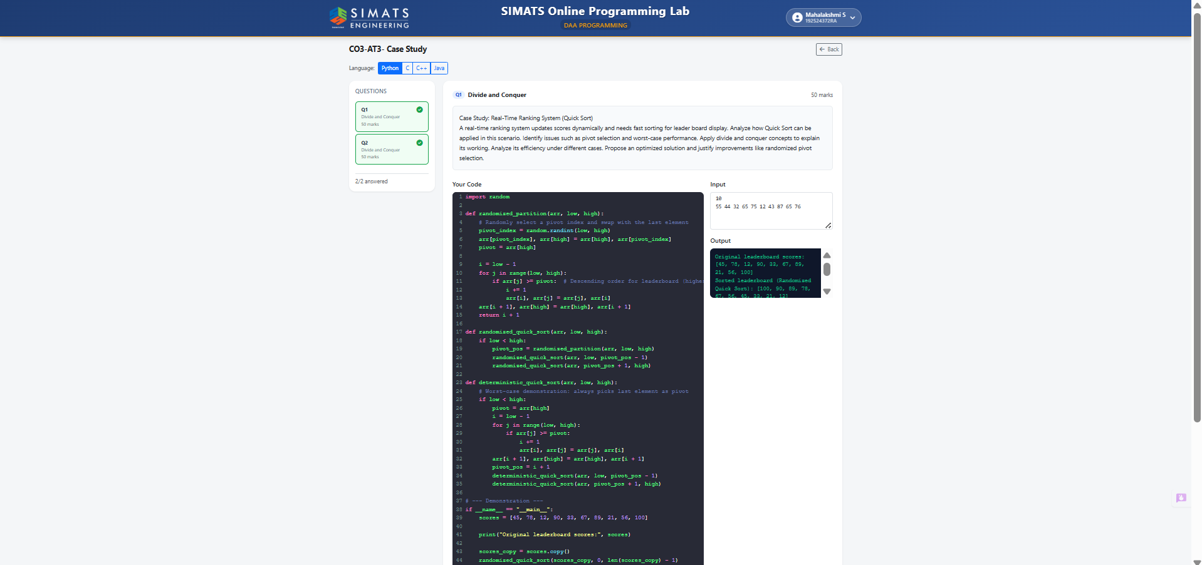

QUESTION 2:
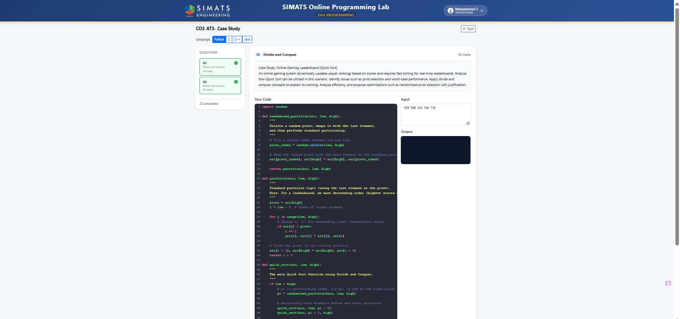

Code of Conduct
I S.MAHALAKSHMI(192524372) (Name / Reg No) certify that this submission is my original work and that I have adhered to the guidelines specified for this assessment. I understand that any violation of academic integrity rules will result in disciplinary action.
Signature of the Student: S.MAHALAKSHMI

RUBRICS FOR CALCULATION
Case Study
Criteria | Weightage | Level 4 – Exemplary | Level 3 – Proficient | Level 2 – Developing | Level 1 – Beginning
Understanding of Case | 25 | Thorough understanding; clearly identifies all key issues | Good understanding with most issues identified | Basic understanding; some issues missed | Poor understanding; problem not identified correctly
Application of Concepts | 25 | Effectively applies relevant concepts to analyze the case deeply | Applies appropriate concepts with minor gaps | Limited application of concepts | Fails to apply relevant concepts
Analysis | 20 | In-depth analysis with strong reasoning and insights | Good analysis with logical reasoning | Basic analysis with limited depth | Weak or no analysis; lacks reasoning
Solution Design | 20 | Innovative, feasible solutions with strong justification | Logical solutions with adequate justification | Basic solutions with weak justification | Incorrect or no solution provided
Clarity | 10 | Clear, well-structured, and easy to understand | Organized and understandable presentation | Limited clarity and structure | Poor clarity; difficult to understand
Mark Evaluation:
Case Study | Understanding of case  (25) | Applications of concepts  (25) | Analysis  (20) | Solution Design  (20) | Clarity  (10) | Total Marks  (Each - 50)
Q1
Q2
Overall Total (100)

Faculty In-charge | Course Coordinator | Head of Department
Name: __________________  Signature: _______________ | Signature: _______________ | Signature: _______________
Date: ___________________ | Date: ___________________ | Date: ___________________

